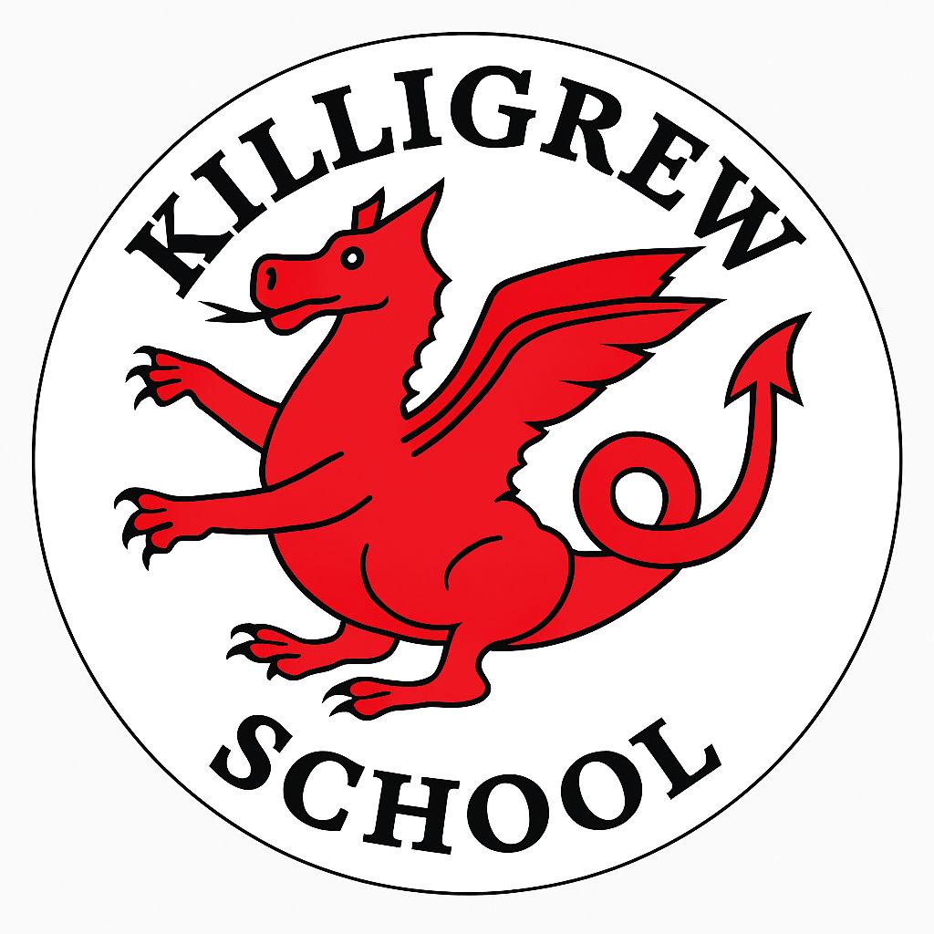
Dates for the Diary 2025-26

Spring Term 2026
Thursday 19th March  2:15pm | Parent Forum meeting for class reps
Friday 20th March | Y2 Cardinals Class Assembly
Friday 27th March | Y1 Goldfinches Class Assembly
Friday 27th March | Last day of term (school closes at 1:15pm)
30th March -10th April | Easter holiday (school closed)
Summer Term 2026
Monday 13th April | Children return to school
Friday 24th April | Reception & KS1 (Y1-Y2) Book Look (parents/grandparents welcome)
Friday 24th April | Y3 Bluejays Class Assembly
Friday 1st May | KS2 (Y3-Y6) Book Look (parents/grandparents welcome)
Friday 1st May | YR Firecrests Class Assembly
Monday 4th May | Bank Holiday (school closed)
Wednesday 6th May – Friday 8th May | Year 5 residential to Tolmers Activity Centre
Friday 8th May | YR Skylarks Class Assembly
Monday 11th-Thursday 14th  May | Year 6 SATS week
Friday 15th May | Y1 Nightingales Class Assembly
Friday 22nd May 9:00am | KS2 Sports Day (parents and grandparents welcome)
Monday 25th-Friday 29th May | Half term holiday (school closed)
Monday 1st June | INSET Day (school closed)
Friday 12th June 2:00pm | EYFS (Nursery and Reception) Sports Day (parents and grandparents welcome)
Tuesday 2nd -Friday 12th June | Y4 multiplication tables check
Monday 8th-Friday 12th June | Y1 phonics screening check week
Friday 19th June  9:15am | KS1 (Y1-Y2) Sports Day (parents and grandparents welcome)
Friday 26th June  3:15 – 3:45pm | KS1 (Y1-Y2) Book look (parents/grandparents welcome)
Friday 3rd July  3:15 – 3:45pm | KS2 (Y3-Y6) Book look (parents/grandparents welcome)
Thursday 9th July | Transition day (meet the new teacher)
Friday 17th July 2:45pm | Mr Mitchell’s concert (parents and grandparents welcome) Classes TBC
Monday 20th July | Last day of term (school closes at 1:15pm)
Tuesday 21st July | INSET Day (school closed)
Wednesday 22nd July | INSET Day (school closed)
Thursday 23rd July | Occasional Day (school closed)
Friday 24th July | Summer holiday (school closed)

