Killigrew Primary School & Nursery

Behaviour Policy

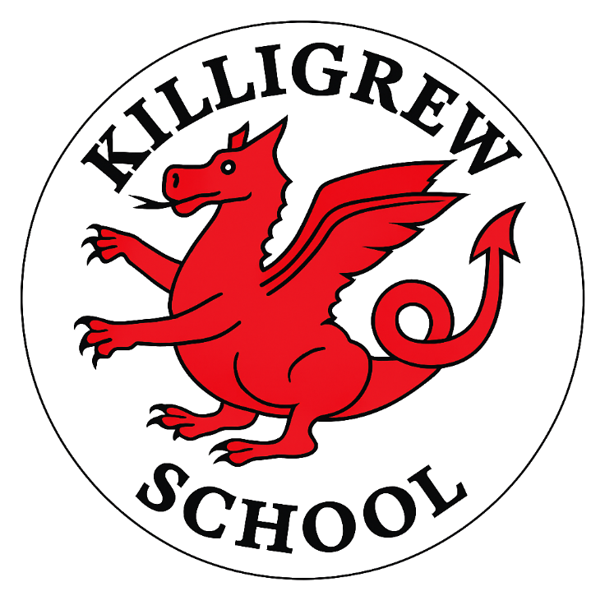

Publish Date: January 2026
Review Date: January 2027

Contents
- Introduction
- Governing Body’s Statement of Behaviour
- Aims & Values
- Communication of the Provisions of this Policy
- General Classroom Positive Behaviour Strategies
- Rules and Consequences
- Staff Development and Support (including volunteers)
- Pupil Support Systems and Restorative Practice
- Liaison with Agencies
- Physical Intervention and the Power to Use Reasonable Force
- Fixed-Term Suspensions and Permanent Exclusions (including zero-tolerance behaviour incidents)
- Malicious Accusations Against School Staff
- Pupils’ Conduct Outside the School Gates
- Confiscation of Inappropriate and/or Prohibited Items (including weapons and drugs) and the Power to Search Without Consent
- Behaviour Consequences Linked to the Inappropriate Use of IT
- Legal Duties Under the Equalities Act 2010
- Safeguarding Procedures and Protocols
- Relevant Documents

1. Introduction
At Killigrew Primary School, our behaviour policy is rooted in our three core values: respect, enthusiasm and determination. These values guide everything we do and reflect our belief in a consistent, whole-school approach that nurtures prosocial behaviours, supports every stage of children’s development, and prepares them to become positive, responsible members of our community.
We are committed to creating a learning environment where all children feel safe, valued and inspired to achieve their best. Supportive relationships, restorative practices and a commitment to equality and diversity sit at the heart of this commitment. By fostering respect for ourselves and others, enthusiasm for learning, and determination in overcoming challenges, we help children understand the impact of their actions and the importance of making thoughtful, responsible choices.
Our restorative approach focuses on connection before correction. Through conversations that encourage reflection and understanding, children learn to repair relationships, develop empathy and take ownership of their behaviour. These principles ensure that pupils leave Killigrew with a strong moral compass, and an awareness of how their choices affect the world around them.
All pupils and parents are informed of our expectations through our Home–School Agreement, shared when a place is accepted. Our behaviour policy—published on the school website alongside our anti-bullying, equalities and safeguarding policies—reflects the aims of the school and outlines how every member of the school community contributes to a positive and inclusive environment.
This behaviour policy links to key school documents (listed in the final section) and reflects our responsibilities under the Equality Act 2010, including safeguarding duties and the care of pupils with special educational needs.

2. Governing Body’s Statement of Behaviour
We believe that everyone involved with our school community has rights and responsibilities to ensure that teaching and learning take place effectively. This includes governors, staff, children and parents. As governors, we share the responsibility of ensuring high standards of behaviour on the part of adults and children alike. Our duty of care encompasses the promotion of behaviour that is positive, reflects our school values and underpins the safety and security of the learning environment. Within this policy, we expect reference to be made to the DfE (Department for Education) (2013) advice linked to the use of reasonable force.

3. Aims & Values
The aim of our behaviour policy is to nurture prosocial feelings and actions, helping children understand themselves, build positive relationships and make choices that support their learning and wellbeing. We recognise that all behaviour is a form of communication, and our approach ensures children learn that their behaviours carry consequences—both positive and negative—that influence their own experiences and those of others.
At Killigrew, our expectations are shaped entirely by our three core values:
Respect, Enthusiasm and Determination.
We refer to these as our RED Behaviours, and they guide every interaction in our school community.

Respect
Children learn to value themselves and others, communicate kindly, celebrate differences and contribute to a safe, inclusive environment.

Enthusiasm
Children show curiosity, positivity and active engagement in learning, helping to create an encouraging and joyful school culture.

Determination
Children build resilience, take responsibility for their actions and persevere through challenges with increasing independence.
Through modelling, teaching and celebrating these RED Behaviours, we support children to become considerate, motivated and responsible individuals who understand the impact of their choices and strive to contribute positively to the school and wider community.
Our behaviour policy is designed so that:
• Children celebrate difference and understand that no form of bullying, racism or sexism is acceptable.
• Children know the difference between right and wrong and do not engage in sexist or sexual name-calling, sexual innuendo (including gestures and noises) or ‘banter’.
• Children respect personal space and know that physical contact should not be uninvited.
• Children are respectful of personal property and that of others.
• Children are taught about equality and diversity in order to challenge stereotypes and discrimination.
• Children are well-mannered, understanding the value of courtesy.
• Children understand the value of acting honestly and respectfully.
• Children are supported, through a restorative approach, to self-regulate and manage heightened emotions.

4. Communication of the Provisions of this Policy
We hold regular assemblies that reinforce our core values of Respect, Enthusiasm and Determination, promote positive behaviours and deepen pupils’ understanding of PSHE and RSE. Celebration assemblies and positive consequences highlight and reward RED Behaviours and strong attitudes to learning.
As outlined in our Teaching and Learning Policy, pupils receive daily feedback that recognises effort and supports reflection. Teachers use calm, supportive conversations to help children understand the impact of their behaviour and take ownership of their choices.
Positive behaviours are promoted through:
• Verbal praise and recognition
• House points
• Golden reward stickers
• Golden tickets
• Awards from the Headteacher and Deputy Headteacher
• Sharing good news with parents/carers
• Newsletter mentions
• Work displays
• Sharing work with senior leaders
The behaviour policy is reviewed regularly with staff and governors and published on the school website.

5. General Classroom Management Strategies
School staff adopt the guidelines in Appendix 1 (Behaviour Stages) to implement and maintain high expectations of behaviour.
• Teachers establish classroom routines at the start of the year and review them regularly.
• Adults are consistent and address incidents from playtime/lunchtime promptly, using restorative approaches.
• Adults act as positive role models, building respectful, supportive relationships.
• Adults understand individual needs and differentiate learning to support engagement.
• Staff seek guidance promptly when needed.
• Adults promote a positive ethos to enhance self-esteem.
• Adults encourage positive behaviour choices and provide alternatives to poor behaviour.
• House points and golden tickets are used consistently to reinforce positive behaviour.
• Adults help pupils recognise and celebrate positive feelings.
• Teachers communicate frequently with parents to highlight positive behaviour.

6. Rules and Consequences
All adults and pupils follow the behaviour stages (Appendix 1.1 and Appendix 1.2). Inappropriate behaviour is minimised through praise and encouragement. Most pupils respond to the school rules; some require additional support.

Stage 1 – Rule Reminder
A quiet, specific reminder of the rule being broken. Children are encouraged to return to RED Behaviours.

Stage 1 – Warning
If behaviour continues, the pupil receives a clear warning naming the rule broken.

Stage 1 – Final Reminder
After three reminders, the behaviour will be discussed outside lesson time (break/lunch) and the pupil may complete a task to make up for lost learning.

Stage 2
If behaviour does not change—or if the incident warrants it—the pupil receives Stage 2. It is recorded on Arbor.
Actions may include:
• Discussion about behaviour
• A formal warning
• Time out (classroom or playground)
• Restorative tasks or completing learning at break/lunch
• Informing the class teacher
• Meeting with Key Stage Lead
• Parent contact if Stage 2 becomes frequent

Stage 3
If behaviour escalates—or warrants immediate Stage 3—it is recorded on Arbor.
Actions may include:
• Parents informed
• SLT discussion
• Restorative tasks / completion of learning
• Missed breaks/lunchtimes until behaviour is deemed safe
• Report card or communication plan if needed
Severe incidents may result in short-term suspension (Headteacher’s discretion).

Stage 4
Applied if Stage 3 behaviour continues or for severe incidents. Recorded on Arbor.
Actions may include:
• Discussion with Headteacher/SLT
• Immediate parent contact
• Internal exclusion
• Report card
• Lunchtime exclusion
• Fixed-term suspension (up to 15 days)
• Permanent exclusion in the most serious cases

General Guidelines for Sanctions
• Adults listen carefully and allow children to explain their actions.
• Only non-humiliating sanctions are used.
• Safety is paramount.
• Midday supervisors and teaching assistants inform teachers of incidents.

Serious Incidents
Incidents involving racism, sexist or sexualised language, sexualised conduct or homophobia must be reported immediately to the Headteacher or Deputy Headteacher. These are recorded, investigated and may result in parent meetings.
Staff must consider safeguarding concerns and record incidents on CPOMS when appropriate. Repeated behaviour concerns may require SENCo involvement.

7. Staff Development and Support (including volunteers)
Staff receive behaviour training during induction. The policy is explained, and behaviour support is provided as needed. Volunteers are given a named contact for queries.
ECTs receive observation opportunities. Support staff and MSAs may have behaviour-focused targets. Additional CPD is offered as necessary.
The leadership team implements the policy, sets expectations and ensures staff access to the full written document.

8. Pupil Support Systems and Restorative Practice
Some pupils need additional support to meet behaviour expectations. Support is tailored, consistently implemented and regularly reviewed with input from staff, senior leaders, SENCo, parents and the pupil.

Pupil Induction
New pupils are introduced to the behaviour stages and RED Behaviours. Information is gathered from previous schools, and records are transferred promptly.

Frequent Behaviour Incidents
Negative incidents are recorded on Arbor and analysed by SLT. Teachers contact parents early if patterns emerge.
Support may include:
• Positive behaviour targets
• Check-ins with Key Stage Leader
• Home/school book
• Nurture support in the Hub
• Quiet rooms for supported learning

9. Liaison with Agencies
Support for complex behaviour may involve referral to The Links Multi Academy Trust Outreach Team. This team can provide therapeutic input and intensive support, including Primary Support Base provision, particularly for children at risk of suspension or exclusion.

10. Physical Intervention and the Power to Use Reasonable Force
Staff may use reasonable force to:
• Prevent pupils committing an offence
• Prevent injury
• Prevent property damage
Staff use de-escalation strategies first and the minimum force necessary.
The Headteacher may conduct searches without consent for prohibited items (as listed in statutory guidance) when they have reasonable grounds.

11. Fixed-Term Suspensions and Permanent Exclusions
Suspensions and exclusions are used only as a last resort. The Headteacher considers protected characteristics under the Equality Act 2010.
Pupils with EHCPs or who are Looked After are especially vulnerable; schools work proactively to avoid exclusion.
The Headteacher uses the civil standard of proof (“more likely than not”) when establishing facts.
‘Cooling off’ off-site is not permitted without following suspension procedures.

Fixed-Term Suspensions
• Maximum 45 days per academic year
• May include lunchtimes (counted as half-days)
• May be followed by further suspension or permanent exclusion

Permanent Exclusion
Reserved for serious or persistent breaches.

Managed Moves
Possible with consent of all parties.
Parents are notified immediately and in writing. The letter must state:
• Whether exclusion is permanent or fixed term and its length
• Reasons for the exclusion
• Parents’ rights to make representations
• How the pupil may participate
• Who to contact
• Right to request records
• Arrangements for education during the first five days
• Details of alternative education thereafter
• Notification to HCC and governors

Governing Body Responsibilities
The governing body must meet within 15 school days if:
• The exclusion is permanent
• Suspension totals exceed 15 days in a term
• A public exam or test will be missed

12. Malicious Accusations Against School Staff
Malicious accusations are taken seriously. Sanctions may include suspension or permanent exclusion. The police or social care may be informed. Staff receive appropriate support.

13. Pupils’ Conduct Outside the School Gates
The school responds to behaviour off-site when pupils:
• Represent the school
• Travel to/from school
• Wear school uniform
• Are identifiable as Killigrew pupils
• Attend residential visits
• Behave in ways that impact school order or reputation
Sanctions follow those outlined in this policy.

14. Power to Search Without Consent & Confiscation
Staff report suspected possession of prohibited items to the Headteacher.
Prohibited items include:
• Knives and weapons
• Alcohol
• Illegal drugs
• Stolen items
• Tobacco and cigarette papers
• Fireworks
• Pornographic images
• Items likely to cause injury or commit an offence
The police are contacted immediately for weapons or extreme/child pornography.
Other items (e.g. recording devices) may be confiscated for up to one week.

15. Behaviour Consequences Linked to the Inappropriate Use of IT
Pupils are taught safe and respectful behaviour online. All IT use in school is supervised. Year 6 pupils may bring phones but must hand them in daily.
Pupils must not send offensive or upsetting messages, including sexist or sexualised language. Only school accounts may be used.
If inappropriate content is sent/received:
• Pupils must report immediately
• Staff record the incident on CPOMS
• Computing lead investigates
• Headteacher is informed
• Parents are contacted
• Sanctions are applied proportionately
• DSL involvement where there is risk of harm
• Police/social care contacted where appropriate

16. Legal Duties Under the Equalities Act 2010
All pupils are entitled to equal opportunities. Stereotyping is not tolerated.
Adjustments are made for pupils with protected characteristics. Behaviour records are kept to monitor patterns and ensure non-discrimination.
Allegations of discrimination are fully investigated. Allegations against the Headteacher are referred to the Chair of Governors.

17. Safeguarding Procedures and Protocols
Staff assess whether behaviour may indicate significant harm and record concerns on CPOMS immediately.
If not a safeguarding matter, staff use restorative coaching conversations to support behaviour reflection. Staff consider whether unmet needs may underlie behaviour.

18. Relevant Documents
a) Behaviour in Schools (February 2024)
b) Behaviour and Discipline in Schools – Guidance for Governing Bodies (2012)
c) Use of Reasonable Force (July 2013)
d) Searching, Screening and Confiscation (July 2022)
e) DfE/ACPO Drug Advice for Schools (September 2012)
f) KCSiE
g) Suspension and Permanent Exclusion Guidance (August 2024)
h) Hertfordshire Exclusions Guidance Supplement (August 2024)
i) HfL Preventing the Rise in School-Aged Sexual Abuse Toolkit (2022)
j) The Kindness Principle – Dave Whitaker (2021)
k) The Attachment Aware and Trauma Informed Toolkit
l) Restorative Practice – Mark Finnis (2021)

